**ABSTRACT**

The abstract outlines the key features and benefits of a user-friendly and efficient food ordering website designed to enhance the dining experience for customers. This website streamlines the process of food selection and delivery, catering to the modern lifestyle where convenience is of utmost importance.

The food ordering website incorporates a responsive and intuitive user interface that allows customers to browse through an extensive menu with various cuisines and dishes. Users can easily search, filter, and customize their orders, ensuring they receive meals tailored to their preferences and dietary requirements.

The food ordering website emphasizes data security, implementing modern encryption standards to protect user information and payment details. Privacy measures are carefully maintained, adhering to industry standards and regulations to instill trust among customers.

Overall, the food ordering website sets a new standard in the digital dining landscape by providing a seamless, convenient, and secure platform for customers to explore diverse culinary options, ensuring a delightful dining experience for all.

.

**TABLE OF CONTENTS**

**PAGE NO.**

**1-4**

**5-19**

**20-21**

**22-23**

**24-26**

**27-40**

**41-45**

**46-49**

**50-51**

**52-53**

**54-56**

**57-58**

**TITLE**

**CHAPTER 1: INTRODUCTION**

**CHAPTER 2: REQUIREMENT ANALYSIS**

**CHAPTER 3: MODULE**

**CHAPTER 4: ER- DIAGRAM**

**CHAPTER 5: DATABASE DESIGN**

**CHAPTER 6: CODING**

**CHAPTER 7: TESTING**

**CHAPTER 8: SCREENSHOTS**

**CHAPTER 9: ANALYSIS AND DESIGN**

**CHAPTER 10: CONCLUSION**

**CHAPTER 11: FUTURE ENHANCEENT**

**CHAPTER 12: BIBLIOGRAPHY**

**CHAPTER 1**

**INTRODUCTION**

**INTRODUCTION**

* Food Ordering Website, a revolutionary platform designed to transform the way restaurants and food businesses manage their orders and operations. With a focus on simplicity, efficiency, and customer satisfaction, this system empowers your establishment to offer a seamless and delightful ordering experience.
* Say goodbye to long queues, order errors, and inefficient workflows. Food ordering system streamlines the entire process, from order placement to payment processing, making it easier for your staff to handle peak hours while ensuring that your customers' needs are met promptly.
* **Objective:**
* The objectives of Food Ordering Website is to manage the details of Food Items, Orders, Order Receipts, Food Stock, Customers. It manages all the information about the System.
* The project is totally made/built at administrative end and thus only administrator is guaranteed the access.
* The build purpose is to reduce the manual works as efforts.
* **Functionalities:**
* Provide the search facilities based on various factors. Such as Food Items, Order Receipt’s, Food stocks, Customers.
* Manages the Login Details online for food Stock details, Customers, etc.
* Track all aspects of information.
* **Scope:**

The scope for a Food Ordering Website includes order management, menu management, online ordering, table management, inventory management, payment processing, reporting, loyalty programs, delivery platform integration, and customer relationship management. It helps streamline operations, improve customer experiences, and adapt to changing trends in the food industry.

* **Existing System:**
* Content Management Systems (CMS): These systems allow for the creation and management of website content without the need for extensive coding knowledge. Popular CMS include WordPress, Drupal, and Joomla
* Server-side scripting languages: These languages allow for the creation of dynamic websites by generating HTML on the server-side, based on user requests. Examples of server-side scripting languages include PHP, Python, and Ruby.
* JavaScript frameworks: These are libraries of pre-written code that can be used to build complex dynamic websites. Examples of JavaScript frameworks include Angular, React.
* **Proposed System:**

The proposed system for a Food Ordering Website aims to provide an efficient and user-friendly platform for restaurants and food establishments to manage their ordering processes, streamline operations, and enhance customer experiences. Here are the key features of the proposed system:

* Order Management: The system will enable easy order entry and tracking, allowing staff to manage dine-in, takeaway, and online orders seamlessly. It will display real-time order status, including order preparation, cooking time, and delivery status.
* Menu Management: The system will offer a simple interface for restaurants to create, modify, and update their menus. They can add new items, set prices, include descriptions, and manage item availability based on inventory.
* Online Ordering: Integration with a user-friendly website and mobile app will enable customers to place orders online, view menu options, make secure payments, and receive order confirmation in real-time.
* Inventory Management: The system will automatically update inventory levels as orders are processed, alerting the management when certain items are running low or out of stock. This helps in effective stock management and reduces wastage.
* Reporting and Analytics: The system will generate comprehensive reports and analytics to help restaurant owners analyze sales trends, popular items, peak hours, and customer preferences. This data-driven approach can guide business decisions and strategies.
* Customer Relationship Management (CRM): The system will include a basic CRM module to capture customer data, preferences, and feedback. This information can be used to personalize services and foster better customer relationships.
* Kitchen Display System (KDS): For busy kitchens, the system will integrate with a Kitchen Display System (KDS) to ensure clear communication between the kitchen and serving staff, minimizing errors and enhancing order accuracy.
* The proposed Food Ordering Website aims to offer a comprehensive solution that simplifies the food ordering process, enhances operational efficiency, and improves overall customer satisfaction. Its user-friendly interface, robust features, and integration capabilities with online platforms will enable restaurants to adapt to the ever-changing demands of the food industry and stay ahead of the competition.

**CHAPTER 2**

**REQUIREMENT ANALYSIS**

**REQUIREMENT ANALYSIS**

* **Problem definition:**
* In this section, we define problems. The problem is that, when results are to be declared, lot of money, physical space, man power is required. And there are so many candidates who needs to get their result, but due to medical illness or some emergency they are not able to visit the institute. Another problem is that, it depends on physical presence of the candidates to get their result.
* **Applications requirements:**

1. **Visual Studio Code:**

* ****Visual Studio Code is an integrated development environment made by Microsoft for Windows, Linux and MACOS. Features include support for debugging, syntax highlighting, intelligent code completion, snippets, code refactoring, and embedded Git. Users can change the theme, keyboard shortcuts, preferences, and install extensions that add additional functionality. Microsoft has released most of Visual Studio Code's source code on GitHub under the permissive MIT License, while the releases by Microsoft are proprietary freeware.
* In the Stack Overflow 2021 Developer Survey, Visual Studio Code was ranked the most popular developer environment tool, with 70% of 82,000 respondents reporting that they use it. Visual Studio Code was first announced on April 29, 2015, by Microsoft at the 2015 Build conference. A preview build was released shortly thereafter. On November 18, 2015, the source of Visual Studio Code was released under the MIT License, and made available on GitHub. Extension support was also announced. On April 14, 2016, Visual Studio Code graduated from the public preview stage and was released to the Web.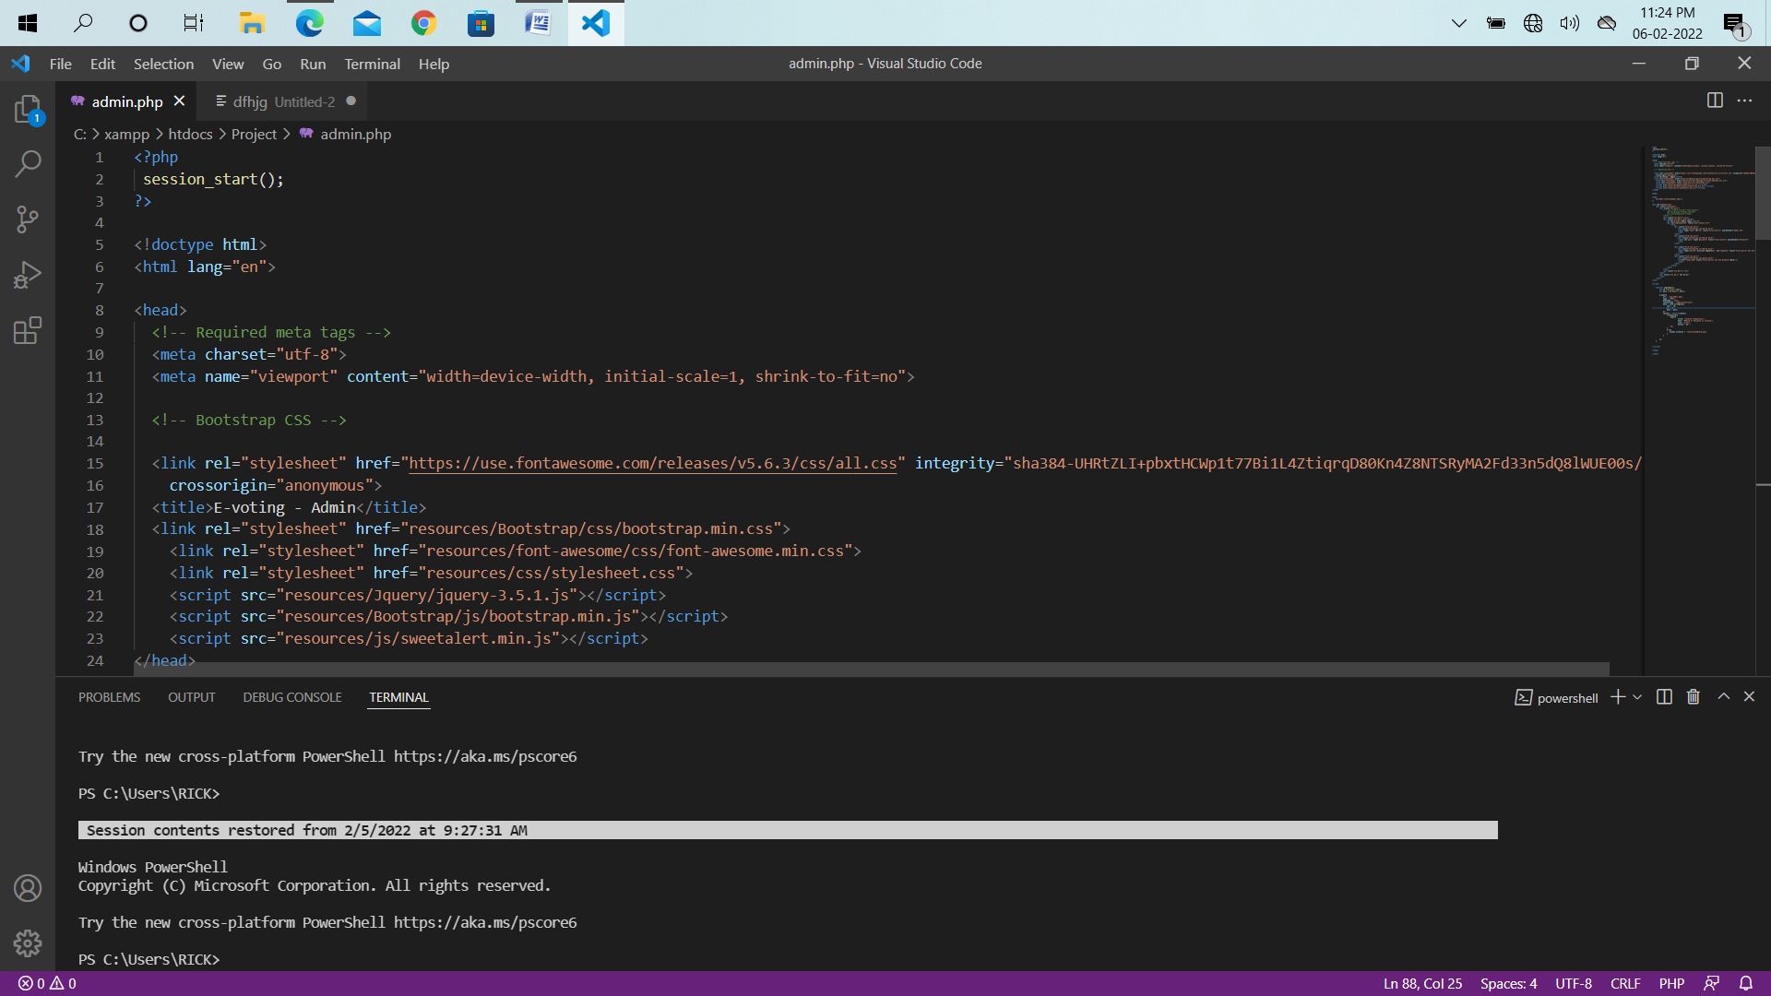

1. **XAMPP:**

* The full form of XAMPP is (X) stands for Cross-platform, (A) Apache server, (M) Maria DB, (P) PHPand (P) Perl. XAMPP is an open source free software developed by Apache friends. XAMPP software package contains Apache distributions for Apache server, Maria DB, PHP, and Perl. And it is basically a local host or a local server. This local server works on your own desktop or laptop computer. You can just install this software on your laptop or desktop and test the clients or your website before uploading it to the remote web server or computer. This XAMPP server software gives you suitable environment for testing MYSQL, PHP, Apache and Perl projects on the local computer.
* The Cross-platform usually means that it can run on any computer with any operating system. Next Maria DB is the most famous database server and it is developed by MYSQL team. PHPusually provides a space for web development. PHPis a server-side scripting language. And the last Perl is a programming language and is used to develop a web application.
* **Main Tools of XAMPP and its Definition:**
* XAMPP contains tools such as Apache, MYSQL, PHP, and Perl. We will see these tools.
* **Apache:**
* Apache server is an open source free software which is initially developed by a group of software developers and now it is maintained by Apache software foundation. Apache HTTP is a remote server (computer) if someone request files, images or documents using their browser they will serve those files to clients using HTTP servers. Mainly hosting companies use this application to create a VPS server and shared hosting for their clients.
* **MYSQL:**
* MYSQL is open-source software. It is actually a relational database management system (RDBMS). This SQL stands for Structured Query Language. It is the most popular and best RDBMS used for developing a variety of web-based software applications. With the help of MYSQL, it is possible to organize the information, manage, retrieve and update the data whenever you wish to do.
* **PHP:**

The full form of PHPis Hypertext Preprocessor. It is a server-side scripting language that helps you to create dynamic websites. This language is mainly used to build web-based software applications. It is open-source software and works fine with MYSQL. What actually happens is, the PHPcode will be executed on the server and at the browser side its HTML code will be displayed.

* **Programming Technology Requirements:**

**HTML:**

* HTML (Hyper Text Markup Language) is the most basic building¬ block of the Web. It defines the meaning and structure of web content. Other technologies besides HTML are generally used to describe a web page's appearance/presentation (CSS) or functionality/behavior (JavaScript). "Hypertext" refers to links that connect web pages to one¬ another, either within a single website or between websites. Links are a fundamental aspect of the Web. By uploading content to the Internet and linking it to pages created by other people, you become an active participant in the World Wide Web.
* HTML uses "markup" to annotate text, images, and other content for display in a Web browser. HTML markup includes special "elements" such as <head>, <title>, <body>, <header>, <footer>, <article>, <section>, <p>, <div>, <span>, <img>, <aside>, <audio>, <canvas>, <datalist>, <details>, <embed>, <nav>, <output>, <progress>, <video>, <ul>, <ol>, <li> and many others.
* An HTML element is set off from other text in a document by "tags", which consist of the element name surrounded by "<" and ">". The name of an element inside a tag is case insensitive. That is, it can be written in uppercase, lowercase, or a mixture. For example, the <title> tag can be written as <Title>, <TITLE>, or in any other way.

**CSS:**

* Cascading Style Sheets (CSS) is a style sheet language used for describing the presentation of a document written in a markup language such as HTML. CSS is a cornerstone technology of the World Wide Web, alongside HTML and JavaScript.
* CSS is designed to enable the separation of presentation and content, including layout, colors, and fonts. This separation can improve content accessibility, provide more flexibility and control in the specification of presentation characteristics, enable multiple web pages to share formatting by specifying the relevant CSS in a separate .css file which reduces complexity and repetition in the structural content as well as enabling the .css file to be cached to improve the page load speed between the pages that share the file and its formatting.
* Separation of formatting and content also makes it feasible to present the same markup page in different styles for different rendering methods, such as on-screen, in print, by voice (via speech-based browser or screen reader), and on Braille based tactile devices. CSS also has rules for alternate formatting if the content is accessed on a mobile device.
* The name cascading comes from the specified priority scheme to determine which style rule applies if more than one rule matches a particular element. This cascading priority scheme is predictable.
* The CSS specifications are maintained by the World Wide Web Consortium (W3C). Internet media type (MIME type) text/css is registered for use with CSS by RFC 2318 (March 1998). The W3C operates a free CSS validation service for CSS documents. In addition to HTML, other markup languages support the use of CSS including XHTML, plain XML, SVG, and XUL.

**JavaScript:**

* JavaScript often abbreviated as JS, is a programming language that conforms to the ECMAScript specification. JavaScript is high-level, often just-in-time compiled, and multi-paradigm. It has curly bracket syntax, dynamic typing, prototype-based object orientation, and first-class functions.
* Alongside HTML and CSS, JavaScript is one of the core technologies of the World Wide Web. JavaScript enables interactive web pages and is an essential part of web applications. The vast majority of websites use it for client side page behavior and all major web browsers have a dedicated JavaScript engine to execute it.
* As a multi-paradigm language, JavaScript supports event driven, functional, and imperative programming styles. It has application programming interfaces (APIs) for working with text, dates, regular expressions, standard data structures, and the Document Object Model (DOM). However, the language itself does not include any input/output (I/O), such as networking, storage, or graphics facilities, as the host environment (usually a web browser) provides those APIs.
* JavaScript engines were originally used only in web browsers, but they are now embedded in some servers, usually via Node.js. They are also embedded in a variety of applications created with frameworks such as Electron and Cordova.
* Although there are similarities between JavaScript and Java, including language name, syntax, and respective standard libraries, the two languages are distinct and differ greatly in design.

**Bootstrap:**

* Bootstrap is a free and open-source CSS framework directed at responsive, mobile-first front-end web development. It contains CSS- and (optionally) JavaScript-based design templates for typography, forms, buttons, navigation, and other interface components.
* Bootstrap is a web framework that focuses on simplifying the development of informative web pages (as opposed to web apps). The primary purpose of adding it to a web project is to apply Bootstrap's choices of color, size, font and layout to that project. As such, the primary factor is whether the developers in charge find those choices to their liking. Once added to a project, Bootstrap provides basic style definitions for all HTML elements. The result is a uniform appearance for prose, tables and form elements across web browsers. In addition, developers can take advantage of CSS classes defined in Bootstrap to further customize the appearance of their contents. For example, Bootstrap has provisioned for light- and dark-colored tables, page headings, more prominent pull quotes, and text with a highlight.
* Bootstrap also comes with several JavaScript components in the form of jQuery plugins. They provide additional user interface elements such as dialog boxes, tooltips, and carousels. Each Bootstrap component consists of an HTML structure, CSS declarations, and in some cases accompanying JavaScript code. They also extend the functionality of some existing interface elements, including for example an autocomplete function for input fields.
* Example of a webpage using Bootstrap framework rendered in Firefox. The most prominent components of Bootstrap are its layout components, as they affect an entire web page. The basic layout component is called "Container", as every other element in the page is placed in it. Developers can choose between a fixed-width container and a fluid-width container. While the latter always fills the width of the web page, the former uses one of the four predefined fixed widths, depending on the size of the screen showing the page:
* Smaller than 576 pixels
* 576–768 pixels
* 768–992 pixels
* 992–1200 pixels
* Larger than 1200 pixels
* Once a container is in place, other Bootstrap layout components implement a CSS Flexbox layout through defining rows and columns.
* A precompiled version of Bootstrap is available in the form of one CSS file and three JavaScript files that can be readily added to any project. The raw form of Bootstrap, however, enables developers to implement further customization and size optimizations. This raw form is modular, meaning that the developer can remove unneeded components, apply a theme and modify the uncompelled Sass files.

**jQuery:**

* JQuery is a JavaScript library designed to simplify HTML DOM tree traversal and manipulation, as well as event handling, CSS animation, and Ajax. [3] It –­­­­­is free, open source software using the permissive MIT License. As of May 2019, jQuery is used by 73% of the 10 million most popular websites. Web analysis indicates that it is the most widely deployed JavaScript library by a large margin, having at least 3 to 4 times more usage than any other JavaScript library.
* JQuery's syntax is designed to make it easier to navigate a document, select DOM elements, create animations, handle events, and develop Ajax applications. jQuery also provides capabilities for developers to create plug-ins on top of the JavaScript library. This enables developers to create abstractions for low-level interaction and animation, advanced effects and high-level, them able widgets. The modular approach to the jQuery library allows the creation of powerful dynamic web pages and Web applications
* The set of jQuery core features—DOM element selections, traversal and manipulation—enabled by its selector engine (named "Sizzle" from v1.3), created a new "programming style", fusing algorithms and DOM data structures. This style influenced the architecture of other JavaScript frameworks like YUI v3 and Dojo, later stimulating the creation of the standard Selectors API. Later, this style has been enhanced with a deeper algorithm-data fusion in an heir of jQuery, the D3.js framework.

* Microsoft and Nokia bundle jQuery on their platforms. Microsoft includes it with Visual Studio for use within Microsoft's ASP.NET AJAX and ASP.NET MVC frameworks while Nokia has integrated it into the Web Run-Time widget development platform.

**Ajax:**

* Ajax is a set of web development techniques using many web technologies on the client side to create asynchronous web applications. With Ajax, web applications can send and retrieve data from a server asynchronously (in the background) without interfering with the display and behavior of the existing page. By decoupling the data interchange layer from the presentation layer, Ajax allows web pages and, by extension, web applications, to change content dynamically without the need to reload the entire page.[3] In practice, modern implementations commonly utilize JSON instead of XML.
* Ajax is not a single technology, but rather a group of¬ technologies. HTML and CSS can be used in combination to mark up and style information. The webpage can then be modified by JavaScript to dynamically display—and allow the user to interact with—the new information. The built-in XML Http Request object, or since 2017 the new "fetch ()" function within JavaScript, is commonly used to execute Ajax on webpages, allowing websites to load content onto the screen without refreshing the page. Ajax is not a new technology, or different language, just existing technologies used in new ways.
* The term Ajax has come to represent a broad group of Web¬ technologies that can be used to implement a Web application that communicates with a server in the background, without interfering with the current state of the page. In the article that coined the term Ajax,[1][3] Jesse James Garrett explained that the following technologies are incorporated:

1. HTML (or XHTML) and CSS for presentation
2. The Document Object Model (DOM) for dynamic display of and interaction with data
3. JSON or XML for the interchange of data, and XSLT for XML manipulation
4. The XMLHttpRequest object for asynchronous communication
5. JavaScript to bring these technologies together

* Since then, however, there have been a number of¬ developments in the technologies used in an Ajax application, and in the definition of the term Ajax itself. XML is no longer required for data interchange and, therefore, XSLT is no longer required for the manipulation of data. JavaScript Object Notation (JSON) is often used as an alternative format for data interchange, although other formats such as preformatted HTML or plain text can also be used. A variety of popular JavaScript libraries, including JQuery, include abstractions to assist in executing Ajax requests.

**PHP:**

* Hypertext Preprocessor is a server side scripting language¬ designed for web development and also used as a general-purpose programming language. It was originally created by Ramus Leadoff in 1994. The PHP reference is now produced by the PHP group. PHP originally stood for personal home page. But now it stands for recursive initialism PHP hypertext preprocessor.
* PHP code may be embedded into html code. It can be used in¬ combination with various web template systems, web content management systems, and web frameworks. PHP code is usually processed by a PHP interpreter implemented as a module in the web server or as a common gateway interface executable. The web server combines the results of interpreted 28 and executed PHP code, which may be any type of data, including images, with the generated web page. PHP code may also be executed with a command line interface and can be used to implement standalone graphical applications.
* The standard PHP interpreter, powered by the Zend engine, is¬ free software released under the PHP license. PHP has been widely ported and can be deployed on most web servers on almost every operating system and platform, free of charge.
* The PHP language evolved without a written formal¬ specification or standard until 2014, with the original implementation acting as the de facto standard.

**What is a PHP File?**

* PHP files can contain text, HTML, CSS, JavaScript, and PHP code.
* PHP code are executed on the server, and the result is returned to the browser as plain HTML.
* PHP files have extension ".PHP".

**What Can PHP Do?**

* PHP can generate dynamic page content
* PHP can create, open, read, write, delete, and close files on the
* server PHP can collect form data
* PHP can send and receive cookies
* PHP can add, delete, modify data in your database
* PHP can be used to control user-access
* PHP can encrypt data
* With PHP we are not limited to output HTML. You can output images, PDF files, and even flash movies. You can also output any text, such as XHTML and XML.

**Why PHP?**

* PHP runs on various platforms (Windows, Linux, UNIX, Mac OS X, etc.)
* PHP is compatible with almost all servers used today (Apache, IIS, etc.)
* PHP supports a wide range of databases
* PHP is free. Download it from the official PHP resource: www.PHP.net
* PHP is easy to learn and runs efficiently on the server side
* PHP is an amazing and popular language!
* It is powerful enough to be at the core of the biggest blogging system on the web (WordPress)!
* It is deep enough to run the largest social network (Facebook)!
* It is also easy enough to be a beginner's first server-side language!

**Advantages of PHP:**

The reason behind the popularity of PHP is its several advantages. PHP is most suited for the purpose of web development. The advantages of PHP are discussed briefly below:

1. **Cross Platform:**

* All the PHP based applications can run on various types of platforms. PHP is supported by majority of Operating Systems, some of which includes Solaris, UNIX, Windows and Linux. The mentioned platforms can be used to write codes in PHP and also view web pages or run the PHP based applications.
* PHP easily interfaces with MySQL and Apache both. An effortless integration of PHP can be done with various other technologies like Java and there is no requirement of redevelopment. Therefore, saving both time and money, giving it an important advantage.

**2. Easy database connection**:

* A programming language like PHP is widely used on the internet and needs to connect to the database very often. Therefore, having a feature that could help PHP to connect to database easily is mandatory. Several websites such as the ecommerce websites require good database management system.
* PHP has a built-in module that helps it in connecting with database easily. Therefore, PHP has a great demand in the field of web development where a data driven website needs to be developed. PHP significantly reduces the time needed in developing the web application that needs an efficient database management system.

1. **Easy to use:**

* PHP is widely used because it is easy to use. In contrast with other programming languages that are complex, PHP is simple, fluent, clean and organized; hence it is a boon for the new users. PHP has a well-organized syntax which is logical at the same time.
* PHP does not require any intensive studying or manual to use it. Command functions of PHP are easily understood as the user can easily figure out from the name of the commands itself what it does. A person who is new to PHP can still code because the syntax is somewhat similar to C.
* A person who is new to PHP can still code because the syntax is somewhat similar to C. Hence, if a person who knows C can easily code in PHP. Hence, it is easier to create and optimize the application using PHP.

1. **Speed:**

* Speed is the primary need of web development. There are people who face the challenge of slow internet connection and slow data speed. Furthermore, a fast-loading website is always preferred by people across the globe. When compared to other programming languages, PHP is found to be the fastest programming language.
* In normal circumstances, it takes a lot of time to connect to the database, when you attempt to fetch certain data from the database. It takes a lot of time in connecting to the database, then executing the statement and finally getting the data. PHP performs these set of tasks faster than other scripting languages. PHP is faster in both connecting to the database and in using other important applications.
* The high speed of PHP gives it an advantage over other scripting languages and gives it an application in important administrations such as the server administration and mail functionalities.

1. **Open source:**

* One of the important advantages of PHP is that it is Open¬ Source. Therefore, PHP is readily available and is entirely free. In contrast to other scripting languages used for web development which requires the user to pay for the support files, PHP is open to everyone, anytime and anywhere.
* A beginner in PHP need not worry about the support as PHP is¬ maintained and developed by a large group of PHP developers which helps in creating support community of PHP that helps people in PHP implementation and manipulation.

* **System minimum requirements:**

**Hardware System Configuration: -**

* Processor - Dual Core/ Pentium/ i3 Intel Processor
* RAM - 2 GB
* Hard Disk - 512MB
* Key Board - Standard Windows Keyboard
* Mouse - Two or Three Button Mouse

**Software System Configuration: -**

* Operating System - Windows XP/7/8/10
* Server-side Script – PHP
* Database - MySQL 6.0

**Research Methodology:**

* A research methodology is the elaboration of a clear strategy for gathering evidence, including the specific data collection methods to be used, the kinds of evidence to be collected, and the approach for analyzing the evidence (Darian-Smith & McCarthy, 2017). It is the path to solve a research problem. Hence it must be planned according to the objectives of the study.

**Data Analysis:**

* The classification and tabulation transfer the raw data collected into useful information by organizing and compiling the bits of data into graphically understandable manner, and in the current research it was done with the help of a UML (Unified Modelling Language) modelling tool.

**System Analysis:**

* Systems development is mainly done in two phases namely, system analysis and design. And this chapter focuses on analyzing the research data and describing a logical view of the whole process, by modelling the data analyzed in the form of diagrams to visualize the design and specifications of the system in an object-oriented manner. The analysis phase answers the questions of who will use the system, what the system will do, and where and when it will be used. During this phase, the research team investigates any current system(s), identifies opportunities for improvement, and develops a concept for the new system.

**System Design:**

* The purpose of the analysis phase is to figure out what the business needs and right after system analysis, started system design whose purpose is to decide how to build the same system. And according to Dennis et al system design is the determination of the overall system architecture consisting of a set of physical processing components, hardware, software, people, and the communication among them, that will satisfy the system’s essential requirements. During the initial part of design, the business requirements for the system are converted into system requirements that describe the technical details for building the system.

**CHAPTER 3**

**MODULE**

**MODULE**

The entire project mainly consists of three modules:

1. Log In

* Admin Login
* Customer Login

1. Add Cashier

* Admin Access to all

1. Manage Products
2. Customer Registration
3. Reviews
4. Gallery Update
5. Logout

**CHAPTER 4**

**ER- DIAGRAM**

**Entity Relationship Diagram:**

* An Entity Relationship (ER) Diagram is a type of flowchart that illustrates how “entities” such as people, objects or concepts relate to each other within a system. ER Diagrams are most often used to design or debug relational databases in the fields of software engineering, business information systems, education and research. Also known as ERDs or ER Models, they use a defined set of symbols such as rectangles, diamonds, ovals and connecting lines to depict the interconnectedness of entities, relationships and their attributes. They mirror grammatical structure, with entities as nouns and relationships as verbs.
* ER diagrams are related to data structure diagrams (DSDs), which focus on the relationships of elements within entities instead of relationships between entities themselves. ER diagrams also are often used in conjunction with data flow diagrams (DFDs), which map out the flow of information for processes or systems.

An entity-relationship diagram (ERD) is a model that shows the logical relationships

and interaction among system entities. An ERD provides an overall view of the

system and a blueprint for creating the physical data structures (Tilley & Rosenblatt,

2017). The following figure displays a logical data representation of the current

proposed system.

An entity-relationship diagram (ERD) is a model that shows the logical relationships

and interaction among system entities. An ERD provides an overall view of the

system and a blueprint for creating the physical data structures (Tilley & Rosenblatt,

2017). The following figure displays a logical data representation of the current

proposed system.

An entity-relationship diagram (ERD) is a model that shows the logical relationships

and interaction among system entities. An ERD provides an overall view of the

system and a blueprint for creating the physical data structures (Tilley & Rosenblatt,

2017). The following figure displays a logical data representation of the current

proposed system.

An entity-relationship diagram (ERD) is a model that shows the logical relationships

and interaction among system entities. An ERD provides an overall view of the

system and a blueprint for creating the physical data structures (Tilley & Rosenblatt,

2017). The following figure displays a logical data representation of the current

proposed system.

An entity-relationship diagram (ERD) is a model that shows the logical relationships

and interaction among system entities. An ERD provides an overall view of the

system and a blueprint for creating the physical data structures (Tilley & Rosenblatt,

2017). The following figure displays a logical data representation of the current

proposed system.

An entity-relationship diagram (ERD) is a model that shows the logical relationships

and interaction among system entities. An ERD provides an overall view of the

system and a blueprint for creating the physical data structures (Tilley & Rosenblatt,

2017). The following figure displays a logical data representation of the current

proposed system. Built with the help of MySQL Workbench, a visual or logical

database design tool which provides data modeling, SQL development, and

comprehensive administration tools for server configuration, user administration,

backup, and much more.

An entity-relationship diagram (ERD) is a model that shows the logical relationships

and interaction among system entities. An ERD provides an overall view of the

system and a blueprint for creating the physical data structures (Tilley & Rosenblatt,

2017). The following figure displays a logical data representation of the current

proposed system. Built with the help of MySQL Workbench, a visual or logical

database design tool which provides data modeling, SQL development, and

comprehensive administration tools for server configuration, user administration,

backup, and much more.

The first step was to identify the entities for the current system during the

analysis phase and at this stage a simplified method can be established to depict the

relationships between entities. The current system database is composed of four tables

representing its respective entities, “disciplina” for subjects, “usuario” for users,

“disciplina_prof” for professors and their assigned subjects, and finally

“disciplina_estudante” for students and the subjects they are enrolled in. And its

composition can be seen in the following figure through the ERD.

**ER- DIAGRAM**

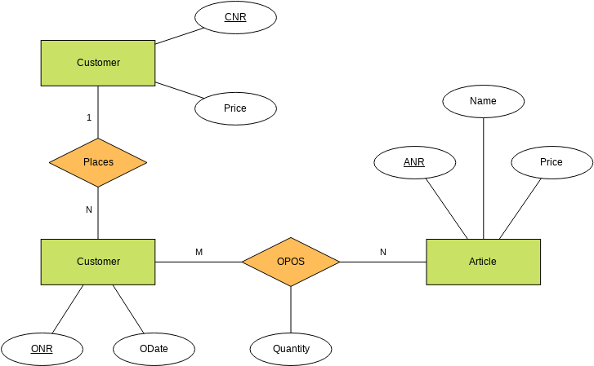

**CHAPTER 5**

**DATABASE DESIGN**

**Database Design:**

* From the analysis phase, a logical model of the system was created. And the following particular activity describes the proposed system’s data organization, storage and management. Which is to be managed by the DBMS a system responsible for storing, retrieving and protecting the data. These issues are important as they affect the consistency and quality of the data. The data is structured in files or tables that interact in various ways. Each table contains data about students, professors, users and subjects. According to Dennis, relational database is the most popular kind of database for application development today. And it is based on collections of tables with each table having a primary key, which is a field or fields whose values are unique for every row of the table and are used to identify each row or record. The tables are related to one another by placing the primary key from one table into the related table as a foreign key. Most relational database management systems (RDBMS) support referential integrity, or the idea of ensuring that values linking the tables together through the primary and foreign keys are valid and correctly synchronized.
* **Design**

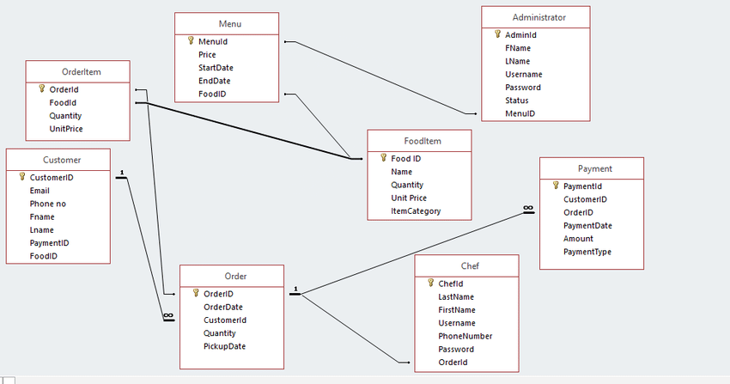

**CHAPTER 6**

**CODING**

**SAMPLE CODE**

**Index:**

<?php session_start(); ?>

<?php include "header.php"; ?>

<!-- Start slides -->

<br>

<div id="slides" class="cover-slides">

<ul class="slides-container">

<li class="text-left">

<img src="images/267.jpg" alt="">

<div class="container">

<div class="row">

<div class="col-md-12">

<h1 class="m-b-20"><strong>Welcome To <br> Food Plaza</strong></h1>

<p class="m-b-40">Have It Your Way,   <br>

World's Greatest Hamburgers</p>

<p><a class="btn btn-lg btn-circle btn-outline-new-white" href="menu.php">Food Menu</a></p>

</div>

</div>

</div>

</li>

<li class="text-left">

<img src="images/1-kathiyawadi-restaurants-1-ki1aq.jpg" alt="">

<div class="container">

<div class="row">

<div class="col-md-12">

<h1 class="m-b-20"><strong>We like  <br> to eat well.</strong></h1>

<p class="m-b-40">Food Plaza is serving a Authentic Food.And Restaurant's

<br> Ambience is a very good with well trained staff with open kitchen concept...</p>

<p><a class="btn btn-lg btn-circle btn-outline-new-white" href="contact.php">Contact Us</a></p>

</div>

</div>

</div>

</li>

<li class="text-left">

<img src="images/DSC_2734.jpg" alt="">

<div class="container">

<div class="row">

<div class="col-md-12">

<h1 class="m-b-20"><strong>Welcome To <br> Yamifood with Food Plaza</strong></h1>

<p class="m-b-40">Deliciousness jumping into the mouth<br>

We know our food..</p>

<p><a class="btn btn-lg btn-circle btn-outline-new-white" href="review.php">Review</a></p>

</div>

</div>

</div>

</li>

</ul>

<div class="slides-navigation">

<a href="#" class="next"><i class="fa fa-angle-right" aria-hidden="true"></i></a>

<a href="#" class="prev"><i class="fa fa-angle-left" aria-hidden="true"></i></a>

</div>

</div>

<!-- End slides -->

<!-- Start About -->

<div class="about-section-box">

<div class="container">

<div class="row">

<div class="col-lg-6 col-md-6 col-sm-12 text-center">

<div class="inner-column">

<h1>Welcome To <span>Food Plaza</span></h1>

<h4>Little Story</h4>

<p>Restaurants in Bangalore.

<a class="btn btn-lg btn-circle btn-outline-new-white" href="contact.php">Contact Us</a>

</div>

</div>

<div class="col-lg-6 col-md-6 col-sm-12">

<img src="images/images.jpg"  width="200%" height="200%" class="img-fluid">

</div>

</div>

</div>

</div>

<!-- End About -->

<!-- Start QT -->

<div class="qt-box qt-background">

<div class="container">

<div class="row">

<div class="col-md-8 ml-auto mr-auto text-center">

<p class="lead ">

" If you're not the one cooking, stay out of the way and compliment the chef. "

</p>

<span class="lead">Food Plaza</span>

</div>

</div>

</div>

</div>

<!-- End QT -->

<!-- Start Menu -->

<div class="menu-box">

<div class="container">

<div class="row">

<div class="col-lg-12">

<div class="heading-title text-center">

<h2>Special Menu</h2>

<p>Enjoy the new Tasty</p>

</div>

</div>

</div>

<div class="row inner-menu-box">

<div class="col-3">

<div class="nav flex-column nav-pills" id="v-pills-tab" role="tablist" aria-orientation="vertical">

<a class="nav-link active" id="v-pills-home-tab" data-toggle="pill" href="#v-pills-home" role="tab" aria-controls="v-pills-home" aria-selected="true">All</a>

<a class="nav-link" id="v-pills-profile-tab" data-toggle="pill" href="#v-pills-profile" role="tab" aria-controls="v-pills-profile" aria-selected="false">KathiyaWadi</a>

<a class="nav-link" id="v-pills-messages-tab" data-toggle="pill" href="#v-pills-messages" role="tab" aria-controls="v-pills-messages" aria-selected="false">RajsThani</</a>

<a class="nav-link" id="v-pills-settings-tab" data-toggle="pill" href="#v-pills-settings" role="tab" aria-controls="v-pills-settings" aria-selected="false">Rise</a>

<a class="nav-link" id="v-pills-tava-tab" data-toggle="pill" href="#v-pills-tava" role="tab" aria-controls="v-pills-tava" aria-selected="false">tava</a>

</div>

</div>

<div class="col-9">

<div class="tab-content" id="v-pills-tabContent">

<div class="tab-pane fade show active" id="v-pills-home" role="tabpanel" aria-labelledby="v-pills-home-tab">

<div class="row">

<?php include "connect.php";

$s = mysqli_query($con,"select * from menu");

while($r = mysqli_fetch_array($s))

{

?>

<div class="col-lg-4 col-md-6 special-grid drinks">

<div class="gallery-single fix">

<img src="admin/<?php echo $r['image']; ?>" class="img-fluid" alt="Image" style='width: 263px; height:170px;'>

<div class="why-text">

<h4><?php echo $r['title']; ?></h4>

<p><?php echo $r['description']; ?></p>

<p>Rs <?php echo $r['price']; ?> /-</p>

<h5 align="center">

<?php if(isset($_SESSION['uid']))

{

?>

<a href="addcart.php?pid=<?php echo $r['id']; ?>&uid=<?php echo $_SESSION['uid']; ?>&price=<?php echo $r['price']; ?>">Add Cart</a></h5>

<?php

}

else

{

?>

<a href="login.php">Add Cart</a>

<?php } ?>

</div>

</div>

</div>

<?php } ?>

</div>

</div>

<div class="tab-pane fade" id="v-pills-profile" role="tabpanel" aria-labelledby="v-pills-profile-tab">

<div class="row">

<?php include "connect.php";

$s = mysqli_query($con,"select * from menu where category='kathiyawadi'");

while($r = mysqli_fetch_array($s))

{

?>

<div class="col-lg-4 col-md-6 special-grid drinks">

<div class="gallery-single fix">

<img src="admin/<?php echo $r['image']; ?>" class="img-fluid" alt="Image" style='width: 263px; height:170px;'>

<div class="why-text">

<h4><?php echo $r['title']; ?></h4>

<p><?php echo $r['description']; ?></p>

<h5>Rs <?php echo $r['price']; ?> /-</h5>

<h5 align="center">

<?php if(isset($_SESSION['uid']))

{

?>

<a href="addcart.php?pid=<?php echo $r['id']; ?>&uid=<?php echo $_SESSION['uid']; ?>&price=<?php echo $r['price']; ?>">Add Cart</a></h5>

<?php

}

else

{

?>

<a href="login.php">Add Cart</a>

<?php } ?>

</h5>

</div>

</div>

</div>

<?php } ?>

</div>

</div>

<div class="tab-pane fade" id="v-pills-messages" role="tabpanel" aria-labelledby="v-pills-messages-tab">

<div class="row">

<?php include "connect.php";

$s = mysqli_query($con,"select * from menu where category='rajsthani'");

while($r = mysqli_fetch_array($s))

{

?>

<div class="col-lg-4 col-md-6 special-grid drinks">

<div class="gallery-single fix">

<img src="admin/<?php echo $r['image']; ?>" class="img-fluid" alt="Image" style='width: 263px; height:170px;'>

<div class="why-text">

<h4><?php echo $r['title']; ?></h4>

<p><?php echo $r['description']; ?></p>

<h5>Rs <?php echo $r['price']; ?> /-</h5>

<h5 align="center">

<?php if(isset($_SESSION['uid']))

{

?>

<a href="addcart.php?pid=<?php echo $r['id']; ?>&uid=<?php echo $_SESSION['uid']; ?>&price=<?php echo $r['price']; ?>">Add Cart</a></h5>

<?php

}

else

{

?>

<a href="login.php">Add Cart</a>

<?php } ?>

</h5>

</div>

</div>

</div>

<?php } ?>

</div>

</div>

</div>

</div>

</div>

</div>

</div>

<!-- End Menu -->

<!-- Start Gallery -->

<div class="gallery-box">

<div class="container">

<div class="row">

<div class="col-lg-12">

<div class="heading-title text-center">

<h2>Gallery</h2>

<p>Delicious food Pictures for Maher Restaurent Listed Here </p>

</div>

</div>

</div>

<div class="tz-gallery">

<div class="row">

<?php

include "connect.php";

$s = mysqli_query($con,"select * from gallery order by id desc limit 6");

while($r = mysqli_fetch_array($s))

{

?>

<div class="col-sm-12 col-md-4 col-lg-4">

<a class="lightbox" href="<?php echo "admin/".$r['image']; ?>">

<img class="img-fluid"  src="<?php echo "admin/".$r['image']; ?>" alt="Gallery Images" style="width: 350px; height: 250px;"

>

</a>

</div>

<?php } ?>

</div>

</div>

</div>

</div>

<!-- End Gallery -->

<!-- Start Customer Reviews -->

<div class="customer-reviews-box">

<div class="container">

<div class="row">

<div class="col-lg-12">

<div class="heading-title text-center">

<h2>Customer Reviews</h2>

<p>"if you build a greater experience, customer tell each other about that, word of mouth is very powerful"</p>

</div>

</div>

</div>

<div class="row">

<div class="col-md-8 mr-auto ml-auto text-center">

<div id="reviews" class="carousel slide" data-ride="carousel">

<div class="carousel-inner mt-4">

<?php include "connect.php";

$s = mysqli_query($con,"select * from review  limit 4");

while($r = mysqli_fetch_array($s))

{

?>

<div class="carousel-item text-center ">

<div class="img-box p-1 border rounded-circle m-auto">

<img class="d-block w-100 rounded-circle" src="images/quotations-button.png" alt="">

</div>

<h5 class="mt-4 mb-0"><strong class="text-warning text-uppercase">

<?php echo $r['name']; ?>

</strong></h5>

<h6 class="text-dark m-0">Review : <?php echo $r['review']; ?></h6>

<p class="m-0 pt-3">

<?php echo $r['description']; ?>

</p>

</div>

<?php } ?>

<div class="carousel-item text-center active">

<div class="img-box p-1 border rounded-circle m-auto">

<img class="d-block w-100 rounded-circle" src="images/quotations-button.png" alt="">

</div>

<h5 class="mt-4 mb-0"><strong class="text-warning text-uppercase">Nilkanth</strong></h5>

<h6 class="text-dark m-0">Review : Good</h6>

<p class="m-0 pt-3">

Good Food, Good Health

</p>

</div>

</div>

<a class="carousel-control-prev" href="#reviews" role="button" data-slide="prev">

<i class="fa fa-angle-left" aria-hidden="true"></i>

<span class="sr-only">Previous</span>

</a>

<a class="carousel-control-next" href="#reviews" role="button" data-slide="next">

<i class="fa fa-angle-right" aria-hidden="true"></i>

<span class="sr-only">Next</span>

</a>

</div>

</div>

</div>

</div>

</div>

<!-- End Customer Reviews -->

<?php include "footer.php"; ?>

**Menu.php:**

<?php session_start(); ?>

<?php include  "header.php"; ?>

<!-- Start All Pages -->

<div class="all-page-title page-breadcrumb">

<div class="container text-center">

<div class="row">

<div class="col-lg-12">

<h1>Special Menu</h1>

</div>

</div>

</div>

</div>

<!-- End All Pages -->

<!-- Start Menu -->

<div class="menu-box">

<div class="container">

<div class="row">

<div class="col-lg-12">

<div class="heading-title text-center">

<h2>Special Menu</h2>

<p>Every day is a good day for your restaurant</p>

</div>

</div>

</div>

<div class="row inner-menu-box">

<div class="col-3">

<div class="nav flex-column nav-pills" id="v-pills-tab" role="tablist" aria-orientation="vertical">

<a class="nav-link active" id="v-pills-home-tab" data-toggle="pill" href="#v-pills-home" role="tab" aria-controls="v-pills-home" aria-selected="true">All</a>

<a class="nav-link" id="v-pills-profile-tab" data-toggle="pill" href="#v-pills-profile" role="tab" aria-controls="v-pills-profile" aria-selected="false">KathiyaWadi</a>

<a class="nav-link" id="v-pills-messages-tab" data-toggle="pill" href="#v-pills-messages" role="tab" aria-controls="v-pills-messages" aria-selected="false">RajsThani</</a>

<a class="nav-link" id="v-pills-settings-tab" data-toggle="pill" href="#v-pills-settings" role="tab" aria-controls="v-pills-settings" aria-selected="false">Rise</a>

<a class="nav-link" id="v-pills-tava-tab" data-toggle="pill" href="#v-pills-tava" role="tab" aria-controls="v-pills-tava" aria-selected="false">tava</a>

</div>

</div>

<div class="col-9">

<div class="tab-content" id="v-pills-tabContent">

<div class="tab-pane fade show active" id="v-pills-home" role="tabpanel" aria-labelledby="v-pills-home-tab">

<div class="row">

<?php include "connect.php";

$s = mysqli_query($con,"select * from menu");

while($r = mysqli_fetch_array($s))

{

?>

<div class="col-lg-4 col-md-6 special-grid drinks">

<div class="gallery-single fix">

<img src="admin/<?php echo $r['image']; ?>" class="img-fluid" alt="Image" style='width: 263px; height:170px;'>

<div class="why-text">

<h4><?php echo $r['title']; ?></h4>

<p><?php echo $r['description']; ?></p>

<p>Rs <?php echo $r['price']; ?> /-</p>

<h5 align="center">

<?php if(isset($_SESSION['uid']))

{

?>

<a href="addcart.php?pid=<?php echo $r['id']; ?>&uid=<?php echo $_SESSION['uid']; ?>&price=<?php echo $r['price']; ?>">Add Cart</a></h5>

<?php

}

else

{

?>

<a href="login.php">Add Cart</a>

<?php } ?>

</div>

</div>

</div>

<?php } ?>

</div>

</div>

<div class="tab-pane fade" id="v-pills-profile" role="tabpanel" aria-labelledby="v-pills-profile-tab">

<div class="row">

<?php include "connect.php";

$s = mysqli_query($con,"select * from menu where category='kathiyawadi'");

while($r = mysqli_fetch_array($s))

{

?>

<div class="col-lg-4 col-md-6 special-grid drinks">

<div class="gallery-single fix">

<img src="admin/<?php echo $r['image']; ?>" class="img-fluid" alt="Image" style='width: 263px; height:170px;'>

<div class="why-text">

<h4><?php echo $r['title']; ?></h4>

<p><?php echo $r['description']; ?></p>

<h5>Rs <?php echo $r['price']; ?> /-</h5>

<h5 align="center">

<?php if(isset($_SESSION['uid']))

{

?>

<a href="addcart.php?pid=<?php echo $r['id']; ?>&uid=<?php echo $_SESSION['uid']; ?>&price=<?php echo $r['price']; ?>">Add Cart</a></h5>

<?php

}

else

{

?>

<a href="login.php">Add Cart</a>

<?php } ?>

</h5>

</div>

</div>

</div>

<?php } ?>

</div>

</div>

<div class="tab-pane fade" id="v-pills-messages" role="tabpanel" aria-labelledby="v-pills-messages-tab">

<div class="row">

<?php include "connect.php";

$s = mysqli_query($con,"select * from menu where category='rajsthani'");

while($r = mysqli_fetch_array($s))

{

?>

<div class="col-lg-4 col-md-6 special-grid drinks">

<div class="gallery-single fix">

<img src="admin/<?php echo $r['image']; ?>" class="img-fluid" alt="Image" style='width: 263px; height:170px;'>

<div class="why-text">

<h4><?php echo $r['title']; ?></h4>

<p><?php echo $r['description']; ?></p>

<h5>Rs <?php echo $r['price']; ?> /-</h5>

<h5 align="center">

<?php if(isset($_SESSION['uid']))

{

?>

<a href="addcart.php?pid=<?php echo $r['id']; ?>&uid=<?php echo $_SESSION['uid']; ?>&price=<?php echo $r['price']; ?>">Add Cart</a></h5>

<?php

}

else

{

?>

<a href="login.php">Add Cart</a>

<?php } ?>

</h5>

</div>

</div>

</div>

<?php } ?>

</div>

</div>

<div class="tab-pane fade" id="v-pills-settings" role="tabpanel" aria-labelledby="v-pills-settings-tab">

<div class="row">

<?php include "connect.php";

$s = mysqli_query($con,"select * from menu where category='rise'");

while($r = mysqli_fetch_array($s))

{

?>

<div class="col-lg-4 col-md-6 special-grid drinks">

<div class="gallery-single fix">

<img src="admin/<?php echo $r['image']; ?>" class="img-fluid" alt="Image" style='width: 263px; height:170px;'>

<div class="why-text">

<h4><?php echo $r['title']; ?></h4>

<p><?php echo $r['description']; ?></p>

<h5>Rs <?php echo $r['price']; ?> /-</h5>

<h5 align="center">

<?php if(isset($_SESSION['uid']))

{

?>

<a href="addcart.php?pid=<?php echo $r['id']; ?>&uid=<?php echo $_SESSION['uid']; ?>&price=<?php echo $r['price']; ?>">Add Cart</a></h5>

<?php

}

else

{

?>

<a href="login.php">Add Cart</a>

<?php } ?>

</h5>

</div>

</div>

</div>

<?php } ?>

</div>

</div>

<div class="tab-pane fade" id="v-pills-tava" role="tabpanel" aria-labelledby="v-pills-tava-tab">

<div class="row">

<?php include "connect.php";

$s = mysqli_query($con,"select * from menu where category='tava'");

while($r = mysqli_fetch_array($s))

{

?>

<div class="col-lg-4 col-md-6 special-grid drinks">

<div class="gallery-single fix">

<img src="admin/<?php echo $r['image']; ?>" class="img-fluid" alt="Image" style='width: 263px; height:170px;'>

<div class="why-text">

<h4><?php echo $r['title']; ?></h4>

<p><?php echo $r['description']; ?></p>

<h5>Rs <?php echo $r['price']; ?> /-</h5>

<h5 align="center"><?php if(isset($_SESSION['uid']))

{

?>

<a href="addcart.php?pid=<?php echo $r['id']; ?>&uid=<?php echo $_SESSION['uid']; ?>&price=<?php echo $r['price']; ?>">Add Cart</a></h5>

<?php

}

else

{

?>

<a href="login.php">Add Cart</a>

<?php } ?></h5>

</div>

</div>

</div>

<?php } ?>

</div>

</div>

</div>

</div>

</div>

</div>

</div>

<!-- End Menu -->

<!-- Start Customer Reviews -->

<div class="customer-reviews-box">

<div class="container">

<div class="row">

<div class="col-lg-12">

<div class="heading-title text-center">

<h2>Customer Reviews</h2>

<p>"if you build a greater experience, customer tell each other about that, word of mouth is very powerful"</p>

</div>

</div>

</div>

<div class="row">

<div class="col-md-8 mr-auto ml-auto text-center">

<div id="reviews" class="carousel slide" data-ride="carousel">

<div class="carousel-inner mt-4">

<?php include "connect.php";

$s = mysqli_query($con,"select * from review  limit 4");

while($r = mysqli_fetch_array($s))

{

?>

<div class="carousel-item text-center ">

<div class="img-box p-1 border rounded-circle m-auto">

<img class="d-block w-100 rounded-circle" src="images/quotations-button.png" alt="">

</div>

<h5 class="mt-4 mb-0"><strong class="text-warning text-uppercase">

<?php echo $r['name']; ?>

</strong></h5>

<h6 class="text-dark m-0">Review : <?php echo $r['review']; ?></h6>

<p class="m-0 pt-3">

<?php echo $r['description']; ?>

</p>

</div>

<?php } ?>

<div class="carousel-item text-center active">

<div class="img-box p-1 border rounded-circle m-auto">

<img class="d-block w-100 rounded-circle" src="images/quotations-button.png" alt="">

</div>

<h5 class="mt-4 mb-0"><strong class="text-warning text-uppercase">Nilkanth</strong></h5>

<h6 class="text-dark m-0">Review : Good</h6>

<p class="m-0 pt-3">

Good Food, Good Health

</p>

</div>

</div>

<a class="carousel-control-prev" href="#reviews" role="button" data-slide="prev">

<i class="fa fa-angle-left" aria-hidden="true"></i>

<span class="sr-only">Previous</span>

</a>

<a class="carousel-control-next" href="#reviews" role="button" data-slide="next">

<i class="fa fa-angle-right" aria-hidden="true"></i>

<span class="sr-only">Next</span>

</a>

</div>

</div>

</div>

</div>

</div>

<!-- End Customer Reviews -->

<?php include "footer.php" ?>

**CHAPTER 7**

**TESTING**

**TESTING**

**Software Testing:**

Software Testing is a method to check whether the actual software product matches expected requirements and to ensure that software product is[Defect](https://www.guru99.com/defect-management-process.html)free. It involves execution of software/system components using manual or automated tools to evaluate one or more properties of interest. The purpose of software testing is to identify errors, gaps or missing requirements in contrast to actual requirements.

**Software Testing is Important** because if there are any bugs or errors in the software, it can be identified early and can be solved before delivery of the software product. Properly tested software product ensures reliability, security and high performance which further results in time saving, cost effectiveness and customer satisfaction.

**Alpha Testing:**

Alpha testing is a type of testing that is done on an application towards the end of a development process when the product is almost in a usable state. This type of testing does not involve functional testing on the application. Instead, it is a user testing on the application in order to understand the user behavior and experience on the application. Normally this test is performed by test engineers, employees and sometimes friends / family members with the aim of trying to emulate around 80% of the customers. While these users test and give their feedback, the development team observes the behavior to check for design issues in the application. Alpha testing is mainly conducted to unveil bugs that might arise due to abrupt errors created by the users, validate the quality state of the software in minimal time and finally propound a build that procures the specifications required. Once this test is executed properly, the software is ready for the next stage, i.e., the beta test. Alpha testing has two phases.

**Black Box Testing:**

Black box testing refers to any type of software test that examines an application without knowledge of the internal design, structure, or implementation of the software project. Black box testing can be performed at multiple levels, including unit testing, integration testing, system testing, or acceptance testing.

1. **Unit Testing: -**

* Unit testing is essentially for the verification of the code produced during the coding phase and the goal is test the internal logic of the module/program. In the Generic code project, the unit testing is done during coding phase of data entry forms whether the functions are working properly or not. In this phase all the drivers are tested they are rightly connected or not.

1. **Integration Testing: -**

* All the tested modules are combined into sub systems, which are then tested. The goal is to see if the modules are properly integrated, and the emphasis being on the testing interfaces between the modules. In the generic code integration testing is done mainly on table creation module and insertion module.

**VALIDATION TESTING**

* This testing concentrates on confirming that the software is error-free in all respects. All the specified validations are verified and the software is subjected to hard-core testing. It also aims at determining the degree of deviation that exists in the software designed from the specification; they are listed out and are corrected.

**SYSTEM TESTING**

* This testing is a series of different tests whose primary is to fully exercise the computer-based system.
* This involves, implementing the system in a simulated production environment and testing it.

**White Box Testing:**

**White Box Testing** is software testing technique in which internal structure, design and coding of software are tested to verify flow of input-output and to improve design, usability and security. In white box testing, code is visible to testers so it is also called Clear box testing, open box testing, transparent box testing, Code-based testing and Glass box testing.

**Beta Testing:**

Beta testing is one of the final steps in your [software development lifecycle](https://www.applause.com/blog/finding-holistic-agile-testing-solutions) (SDLC) before a product goes live. Also referred to as user testing or customer validation, beta testing aims to ensure that end users are satisfied with a software product before you make it generally available (GA). While beta tests want to catch any software bugs and errors that have snuck through the testing process, it is more about understanding and improving the product’s full end user experience before it becomes GA. That means thoroughly investigating the experience flow and understanding any pain points that will hinder enjoyment of the experience for your end user.

**Positive Test Cases:**

* The positive flow of the functionality must be considered
* Valid inputs must be used for testing
* Must have the positive perception to verify whether the requirements are justified.

**Negative Test Cases:**

* Must have negative perception
* Invalid inputs must be used for test.

**Feasibility Study:**

* The next step in analysis is to verify the feasibility of the proposed system. “All projects are feasible given unlimited resources and infinite time “. But in reality, both resources and time are scarce. Project should confirm to time bounce and should be optimal in their consumption of resources. This place a constant is approval of any project.
* Feasibility has applied to the following areas:

Technical feasibility

Operational feasibility

Economic feasibility

**TECHNICAL FEASIBILITY:**

* To determine whether the proposed system is technically feasible, we should take into consideration the technical issues involved behind the system.

**OPERATIONAL FEASIBILITY:**

* To determine the operational feasibility of the system we should take into consideration the awareness level of the users. This system is operational feasible since the users are familiar with the technologies and hence there is no need to gear up the personnel to use system. Also, the system is very friendly and to use.

**ECONOMIC FEASIBILITY:**

To decide whether a project is economically feasible, we have to consider various factors as:

* Cost benefit analysis
* Long-term returns
* Maintenance costs

**CHAPTER 8**

**SCREENSHOTS**

**Login Page:**

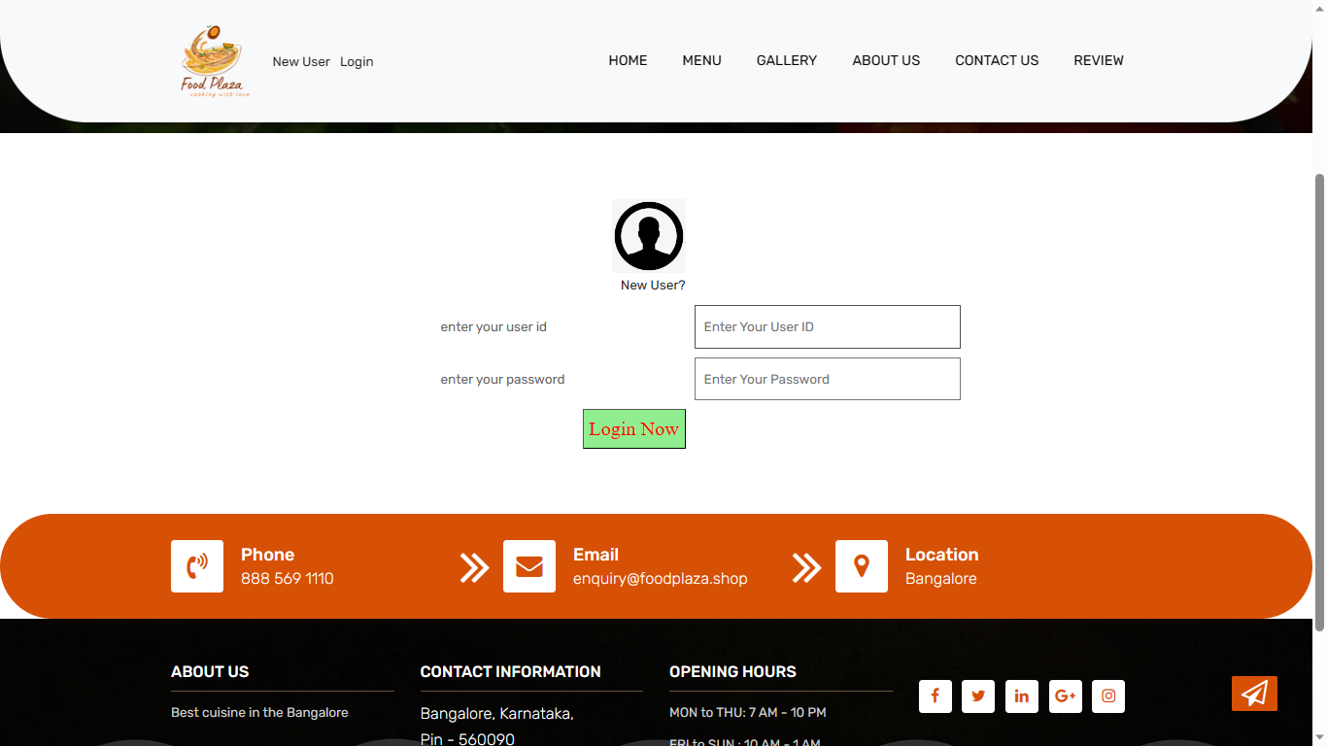

**Admin Dashboard:**

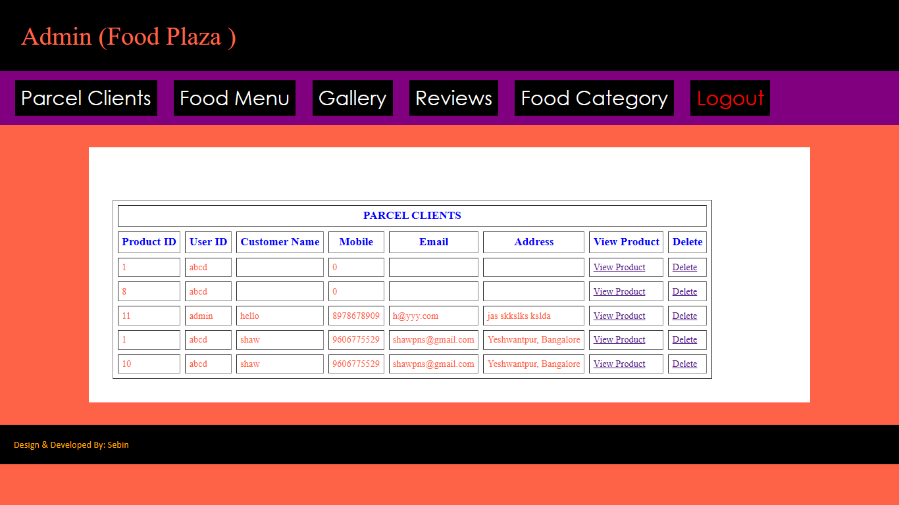

**Product’s Page(Admin):**

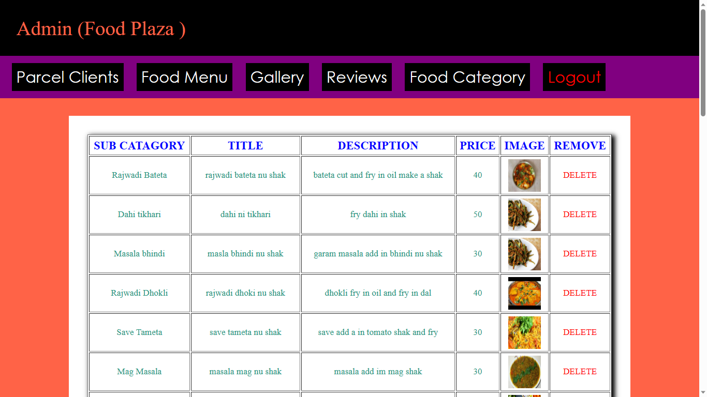

**Home Page:**

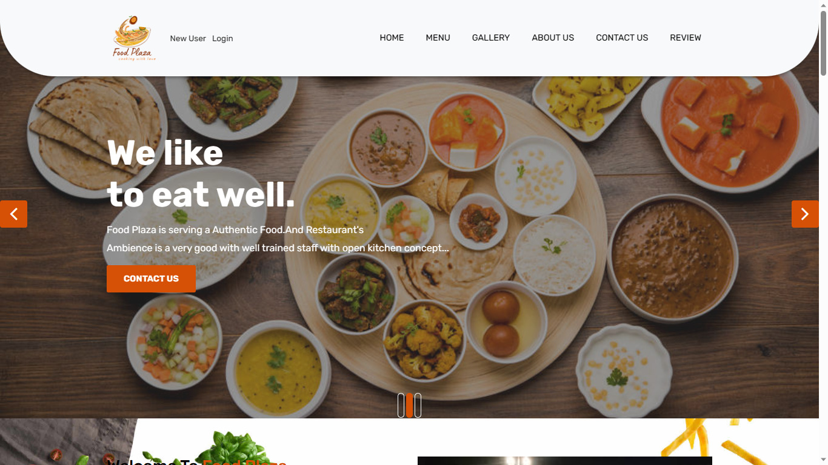

**Menu Page:**

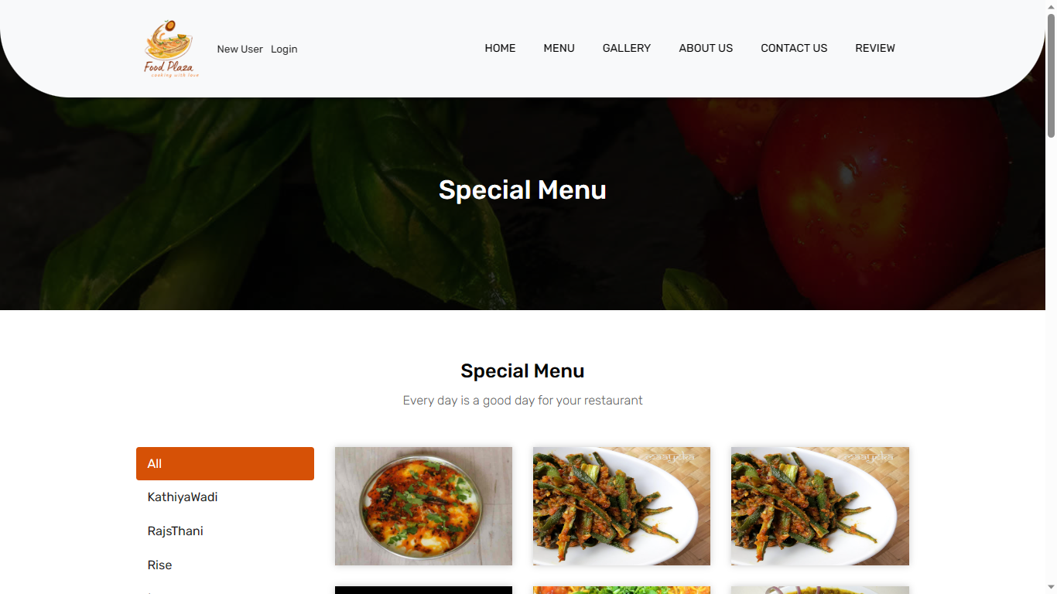

**Website Gallery:**

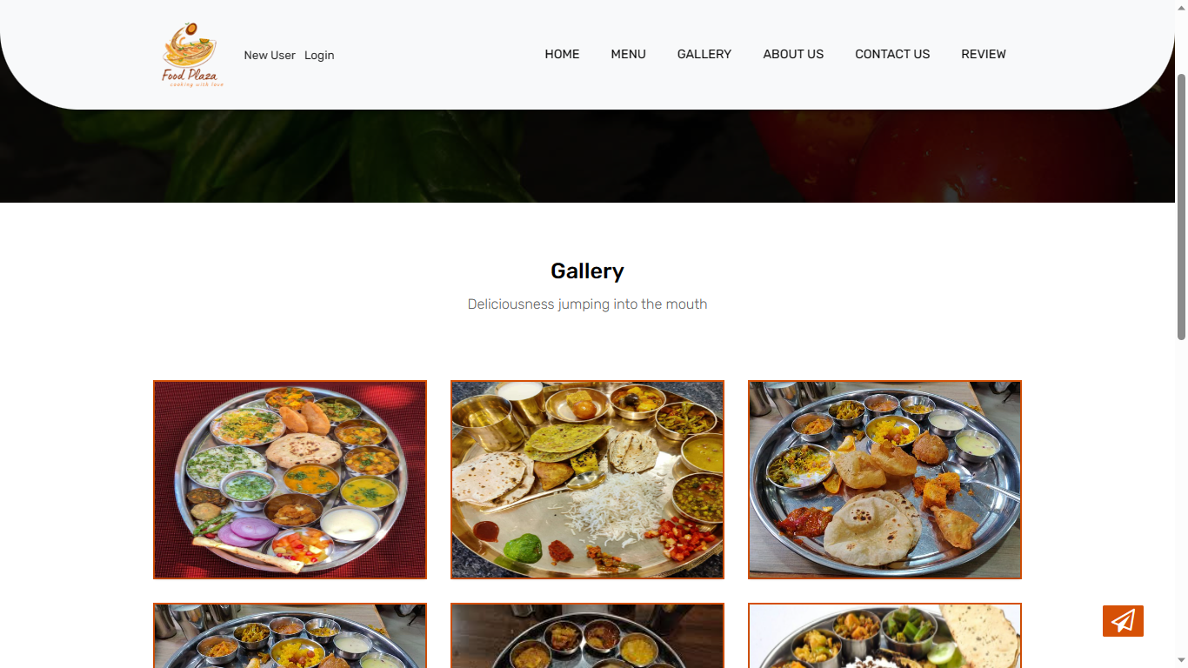

**Gallery Update (Admin):**

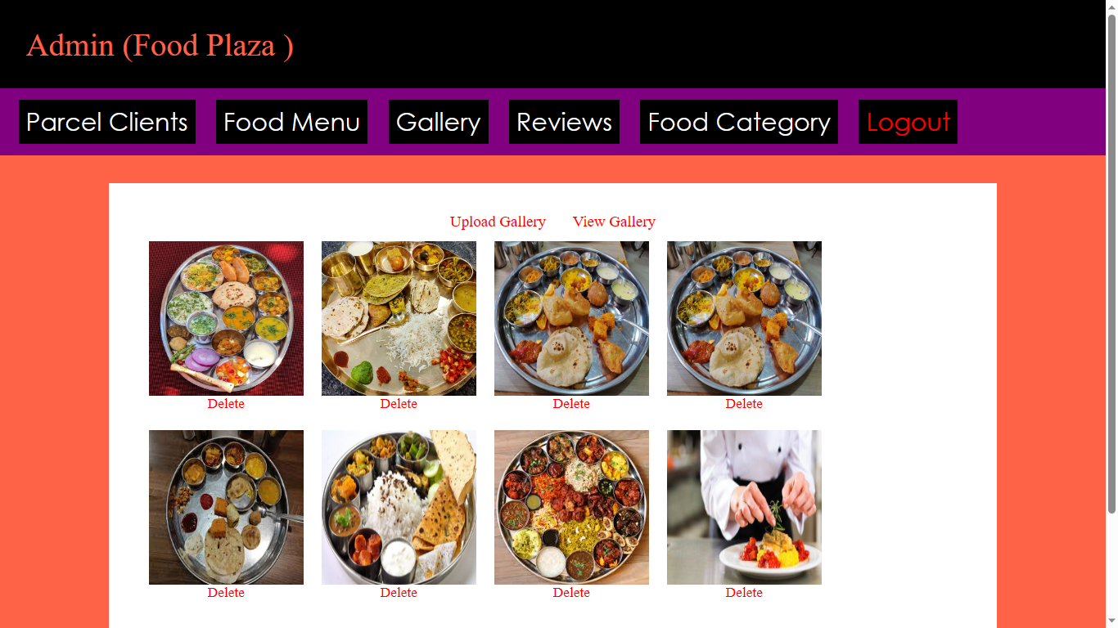

**CHAPTER 9**

**ANALYSIS AND DESIGN**

**Use Case Diagram:**

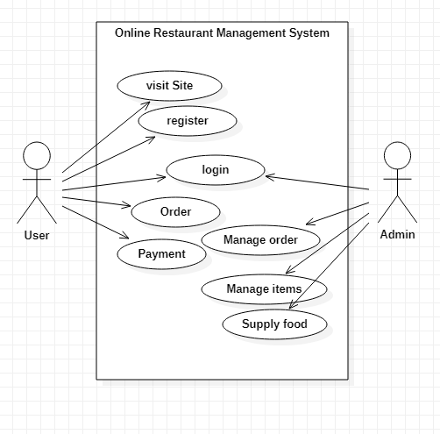

**Database Schema:**



**CHAPTER 10**

**CONCLUSION**

**CONCLUSION**

The restaurant food ordering system is a crucial technological advancement that significantly enhances the dining experience for both customers and restaurant owners. Through this system, customers can conveniently place orders and make reservations, while restaurant owners can efficiently manage their operations and provide a seamless service.

In conclusion, the restaurant food ordering system brings numerous benefits to the table:

* Enhanced Customer Convenience: The system allows customers to place orders online or through mobile apps, providing them with the flexibility to order from the comfort of their homes or on-the-go. This convenience saves time and effort for the customers, leading to increased customer satisfaction and loyalty.
* Streamlined Operations: The system streamlines the order-taking process for restaurant staff, reducing the likelihood of errors and miscommunication. It also facilitates efficient management of reservations, ensuring optimal utilization of the restaurant's capacity and resources.
* Increased Order Accuracy: By eliminating the need for manual order-taking, the system minimizes the chances of errors in the order, ensuring that customers receive exactly what they intended to order. This accuracy enhances the overall dining experience.
* Order Customization: The system often allows customers to customize their orders based on their preferences or dietary restrictions. This level of personalization enhances customer satisfaction and builds a positive perception of the restaurant.
* Real-Time Menu and Pricing Updates: The digital nature of the system enables real-time updates of menus and prices. This ensures that customers are always presented with the latest offerings and accurate pricing, fostering transparency and trust.
* Customer Data and Insights: The system can gather valuable customer data, including ordering habits, preferences, and feedback. Restaurants can leverage this information to tailor their offerings, marketing strategies, and improve overall customer experience.
* Sustainability Benefits: By reducing the need for physical menus and printed receipts, the system contributes to the restaurant's eco-friendliness and sustainability efforts.

Overall, the restaurant food ordering system serves as a valuable tool for modern eateries, contributing to increased efficiency, customer satisfaction, and profitability. Embracing this technology allows restaurants to stay competitive in a rapidly evolving industry and adapt to changing consumer preferences, ensuring long-term success

**CHAPTER 11**

**FUTURE ENHANCEENT**

**FUTURE ENHANCEMENT**

As technology continues to advance, there are several future enhancements that can further improve the restaurant food ordering system and elevate the dining experience for customers. Here are some potential future enhancements:

* Artificial Intelligence (AI) and Personalization: Integrating AI into the system can enable personalized menu recommendations based on customers' previous orders, preferences, and dietary restrictions. The system can also suggest add-ons or complementary items to enhance the upselling potential.
* Augmented Reality (AR) Menu Visualization: AR technology can be used to provide customers with an interactive, virtual representation of dishes on the menu. Customers can view 3D models of the dishes, helping them make more informed choices and reducing any uncertainty about what the dish may look like.
* Contactless Payments and Ordering: Building on the existing trend of contactless payments, future enhancements might integrate more advanced payment methods, such as biometric authentication, allowing customers to pay seamlessly without touching any surfaces.
* Wait-Time Prediction: By analyzing historical data and current restaurant traffic, the system can predict wait times for table reservations or food preparation, allowing customers to plan their dining experience better.
* Multi-Language Support: Offering multi-language support in the ordering system can cater to a more diverse customer base and accommodate tourists who might not be fluent in the local language.
* Enhanced Loyalty Programs: Expanding loyalty programs through the system can reward customers for their repeat business and incentivize them to choose the restaurant over competitors. This could include personalized offers, discounts, or exclusive access to new menu items.
* Integration with Social Media: Allowing customers to share their dining experiences or favorite dishes directly from the ordering system to social media platforms can boost the restaurant's online presence and word-of-mouth marketing.
* Sustainable Packaging Options: Introducing sustainable and eco-friendly packaging choices for takeout and delivery orders can align with customers' growing environmental concerns and enhance the restaurant's image.
* Customer Feedback and Sentiment Analysis: Employing sentiment analysis on customer feedback can provide valuable insights into their experiences and help restaurants identify areas for improvement and potential menu adjustments.

By continuously innovating and embracing emerging technologies, restaurant food ordering systems can stay relevant and continually meet customers' evolving needs and expectations. These enhancements not only optimize restaurant operations but also strengthen the relationship between restaurants and their customers

**CHAPTER 12**

**BIBLIOGRAPHY**

**BIBLIOGRAPHY**

**Programming languages:**

• <https://www.w3schools.com>

• <https://www.javapoint.com>

• <https://www.youtube.com>

• <https://www.wikipedia.com>

• [https://getbootstrap.com](https://getbootstrap.com/)

**Software:**

* [www.apachefriends.org](https://www.apachefriends.org/)
* [visualstudio.com](https://code.visualstudio.com/)

**References:**

* Varsha Chavan, Priya Jadhav, Snehal Korade, Priyanka Teli, ”Implementing Customizable Online Food Ordering System Using Web Based Application”, International Journal of Innovative Science, Engineering Technology(IJISET) 2015
* Patel Krishna, Patel Palak, Raj Nirali, Patel Lalit,” Automated Food Ordering System”, International Journal of Engineering Research and Development (IJERD) 2015.
* Awojide, Simon, I. M. Omogbhemhe, O. S. Awe, and T. S. Babatope, “Towards the digitalization of Restaurant Business Process for Food Ordering in Nigeria Private University: The Design Perspective. A Study of Samuel Adegboyega University Edo State Nigeria,” Int. J. Sci. Res. Publ., vol. 8, no. 5, pp. 46–54, 2018
* mysql code [online] available at www.stackoverflow.com